Granlund datasets explanation

Dear hackers, please read this before using the dataset.

We are providing data on the following subjects:

1. Energy
2. IAQ
3. Sickness data
4. Occupancy
5. Emotions
6. Commuting
7. Productivity
8. Waste

# Energy General

Converting energy to carbon emissions

* Electricity per MW = 220 kg/CO2
* Heating per MW = 186 kg/CO2

## Electric energy consumption

In this dataset you will find **measured electricity consumption** for the period of 12.9. - 25.9.2016. **Measurements are collected hourly as kWh**, which represents hourly consumption from the beginning of specified hour until the end of that hour, i.e. measurement at hour 15:00 means energy consumed from that time until next hour (16:00).

As energy (kWh) is cumulative value for certain timeframe (in this dataset 1 hour) **the data can't be interpolated!**

This dataset consists of 4 csv files with measurements, in **the first three you can find electricity consumed per floor** for the interior lighting, equipment (from power sockets) and their total. In the fourth file **"Other-el-cons",** you can find electricity consumption of **parking garage, real estate electricity** (everything that is not included in other categories, such as energy consumed by ventilation, exterior lighting, elevators, staircases, etc.), **water chiller** (cooling system) and **total building electrical energy consumption**.

**Underneath you can find images describing measurement areas of every floor of the building.**

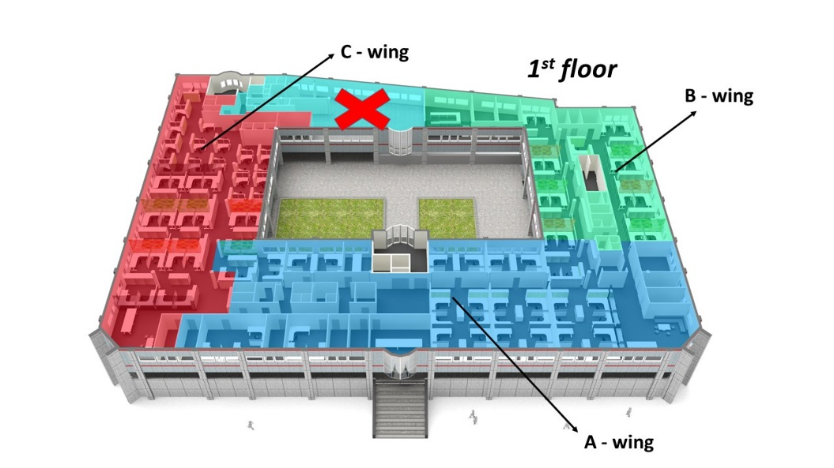

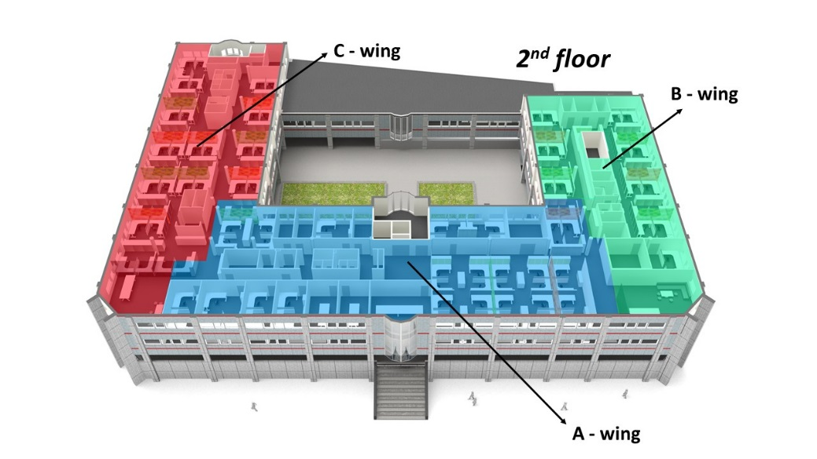

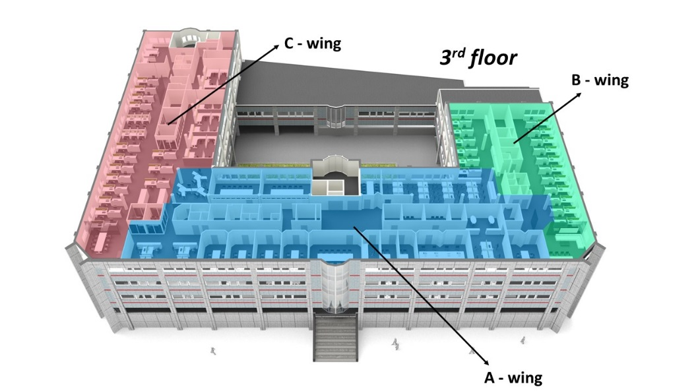

## Heating energy consumption

Under the energy dataset, we have attached monthly heating energy consumption (*heat_en_cons.csv*) (**in MWh**) for the period of 1 year. Sorry guys, we couldn’t get hourly values ☹

# IAQ General

IAQ Targets

• Temperature 20.5-22.5 degrees C

• VOC < 25%

• CO2 < 750

## IAQ1 dataset

In IAQ1 dataset measurements are extracted from the building management system. Sensors included are room temperature sensors, CO2, sensors, humidity sensors, VOC (volatile organic compound) sensor and outdoor temperature sensor. Readings are given in timespan of 15 minutes collected on dates between 12.9. – 25.9.2016. Dataset consists of two files: first one (*IAQ1.csv*) contains measured values with time and sensor ID, while second file (*IAQ1_Sensor_definitions.csv*) contains explanation what type of the sensor it is and where it is located. Room locations can be extracted from provided IFC file of the building (it is possible that some rooms can’t be matched, but for this challenge it shouldn’t matter).

## IAQ2 dataset

IAQ2 dataset consists of following variables which were measured with sensors:

* Temperature
* Humidity
* Pressure
* Illuminance

Data was acquired between 12.09. - 25.09.2016 in 10 seconds timespan.

.csv data structure:

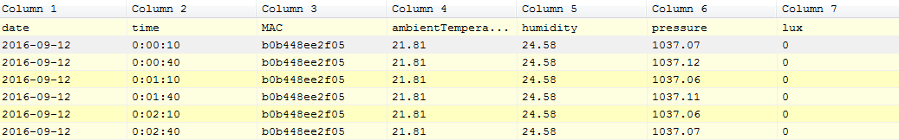

Around the office 5 sensors are spread and their position is shown in figure below, while their name and MAC address are shown in the table.

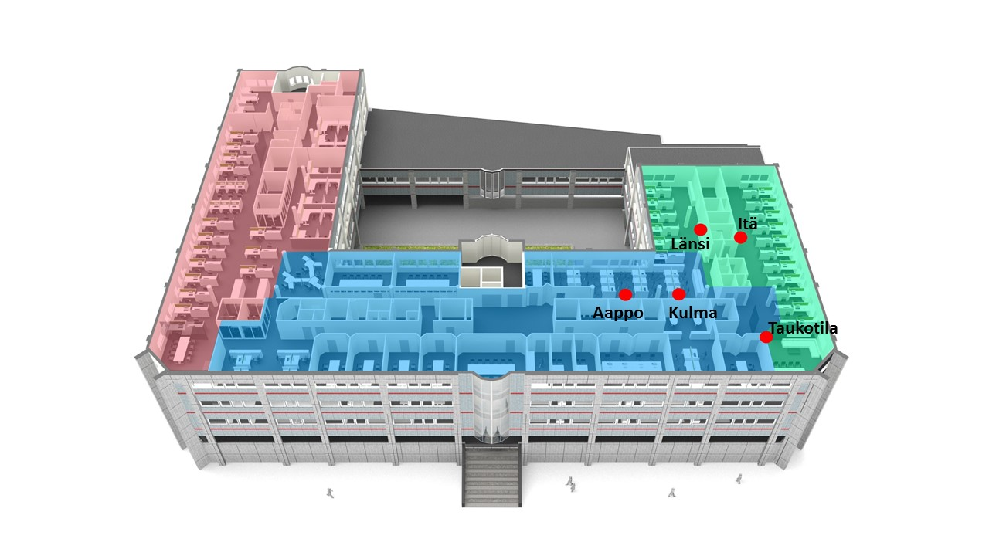

|  |  |
| --- | --- |
| Sensor name | Sensor MAC address |
| Aappo | a0e6f8b67580 |
| Kulma | a0e6f8ae3306 |
| Taukotila | 247189197f80 |
| Itä | 247189198103 (changed to 247189c06f04 on 21.09.) |
| Länsi | b0b448ee2f05 (changed to a0e6f8af4f84 on 23.09.) |

## Meeting room CO2 and schedule

In this dataset we are providing meeting schedules of one of the meeting rooms together with CO2 data from the same time span. In the file (CO2_*meeting-attendees.csv*) together with time and duration of the meeting, the number of attendees is provided. In another file (*CO2_meeting_room.csv*) you can find CO2 concentration in ppm (parts per million) in the meeting room. CO2 concentration is given in 15 min intervals. The more people are there in a closed space, the more CO2 concentration is going to raise, this is minimized with fresh air ventilation, but sometimes the designed ventilation rate isn’t good enough. **Indoor air quality is better if CO2 concentration is lower and it is recommended that it is under the value of 750 ppm (in this meeting room).**

# Sickness

For the month of September we are providing absenteeism data (*sickness_data.csv*) for the same office building. Dataset provides number of hours certain employee has reported as absent due to sickness. Keep in mind that official working day amounts 7,5 hours. Meaning if value in dataset shows 7,5 it means that person was absent full working day.

# Occupancy dataset

Occupancy dataset consists of 2 files with different sources of data. One (*avg_occupancy_rate.csv*) is occupancy rate collected using cameras & people counting software presented as an average working week. Occupancy rate is given as a ratio from 0 to 1, where 1 means fully occupied building (office building with approx. 350 employees).

In other file (*access_control_data.csv*) you can find output from access control (clock in) system, i.e. cumulative number of people clocking in or out during the day, for the period of 2 weeks 12.9. - 25.9.2016.

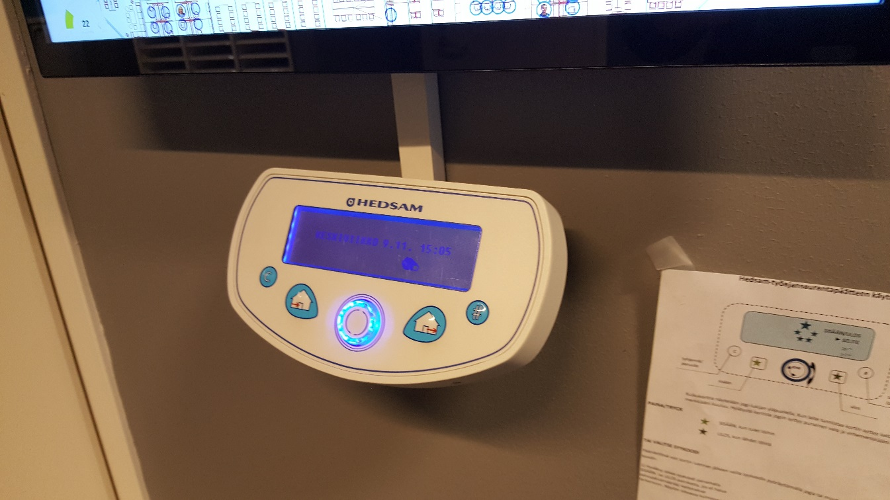

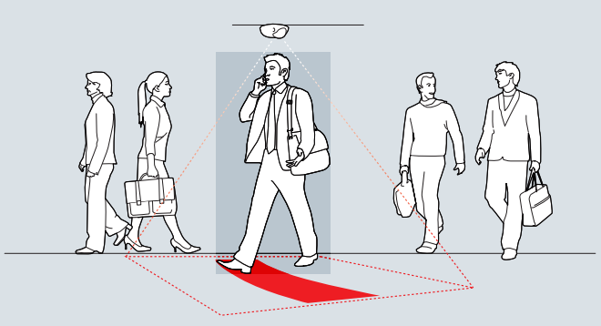

# Emotions

Emotions dataset is given in three parts, one comes from bttns (*bttns-data.csv*) which are placed around the building, second (*web-interface-data.csv*) from online interface, while third file contains people’s comments that are provided via the web interface (*comments.csv*). Please note that the comments are in Finnish. In the bttns file, ID of a button is given at a time when someone presses it.

Please note:

* hymynaama = smiley face
* ruttunaama = fromw face

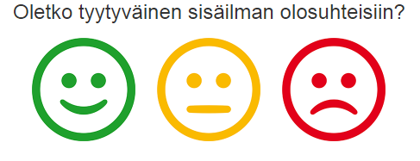

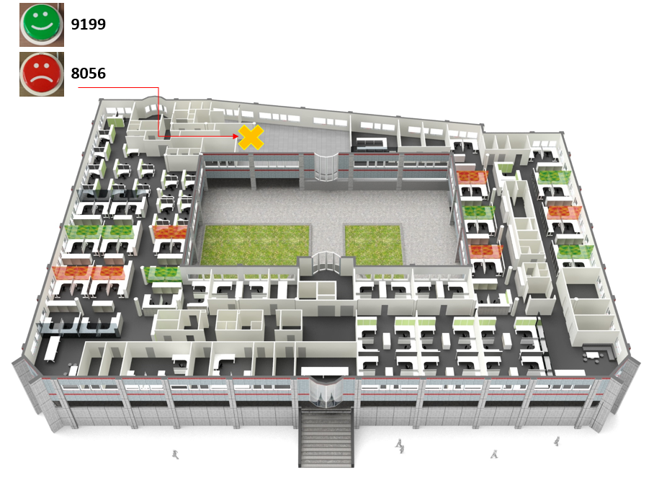

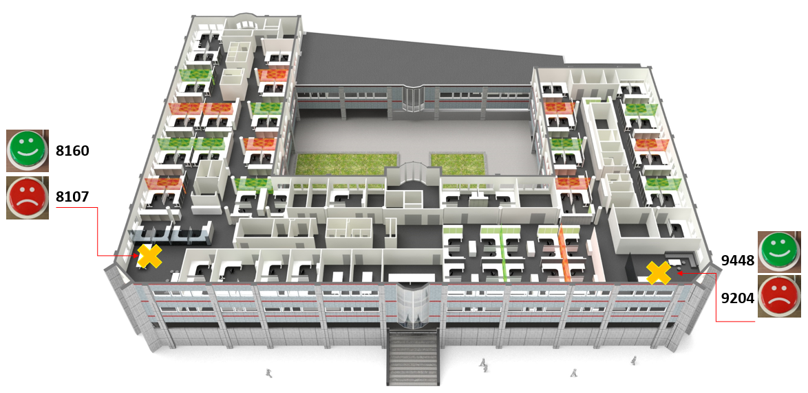

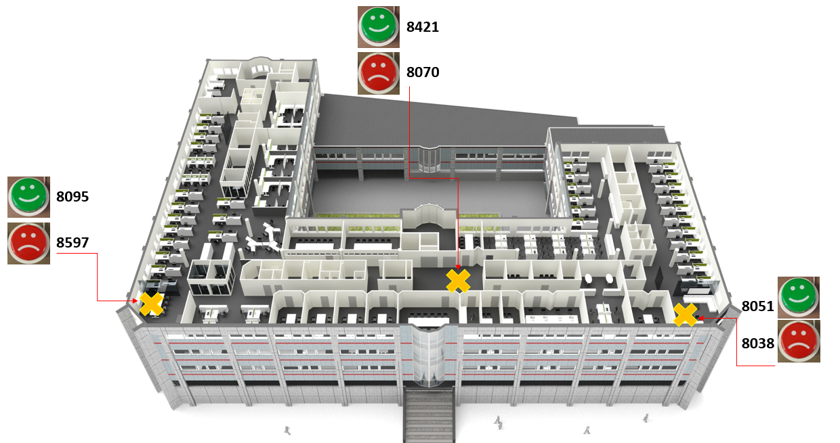

# Commuting

Commuting data shows the commuting patterns of the employees. It describes how they travel to work and how long their journeys are. The data is not here for all employees but is here for most of them.

Some carbon dioxide conversion factors may be seen below.

|  |  |
| --- | --- |
| **Mode of Transport** | **Conversion factor (kgCO2 Eq/ km)** |
| **Walk** | 0,000 |
| **Cycle** | 0,000 |
| **Train** | 0,015 |
| **Tram** | 0,030 |
| **Metro** | 0,013 |
| **Car Petrol Small ≤ 1.4ltr** | 0,205 |
| **Car Petrol Medium 1.5-2.0ltr** | 0,254 |
| **Car Petrol Large >2.0ltr** | 0,354 |
| **Car Small ≤ 1.4ltr** | 0,175 |
| **Medium 1.5-2.0ltr** | 0,217 |
| **Large >2.0ltr** | 0,294 |
| **Motorbike < 125cc** | 0,103 |
| **Motorbike 125 - 500cc** | 0,125 |
| **Motorbike > 500cc** | 0,165 |

# Productivity

Productivity data is shown for each of the 9 wings (ie 3 per floor x 3). This has been calculated by analysing the billable hours for each employee in each zone. Non-billable hours are non-project / non-client specific tasks like holiday, training, sickness, marketing, general work that is not billed to a client.

# Waste

The waste generated by the building is described in this data set. There are 3 different waste streams

# Other useful data

* Rent of the building 220 €/m2/year
* Hours when the building is open (ie doors not locked) 06:00- 22:00
* Floor area 7000 m2